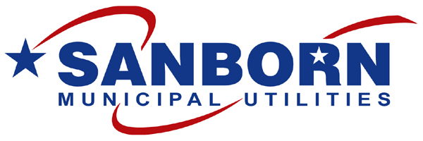
SANBORN MUNICIPAL UTILITIES
102 Main Street - P.O. Box 548
Sanborn, IA 51248-0548

Office: 712-930-3842
FAX: 712-930-3060

AUTHORIZATION for ELECTRONIC BILL PAYMENTS

I hereby authorize Sanborn Municipal Utilities to initiate automatic debits for the payment of my utility bill(s) from the listed bank account. Debit entries will occur on the selected date each month:

1st of month 8th of month 15th of month

( ) Checking Account #
( ) Savings Account #
BANK ROUTING NUMBER
*Routing number may be supplied by your financial institution, or you may attach a voided check or deposit slip to this form

BANK NAME
CITY STATE

This authorization is to remain in effect until Sanborn Municipal Utilities has received notification from me of its termination in such a time and manner as to allow Sanborn Municipal Utilities a reasonable opportunity to act on the request.

CUSTOMER:
Print

Signature: X Date:

Signature: X Date:

ATTN: SANBORN SAVINGS BANK
DEPOSIT TO: Sanborn Municipal Electric General Fund

Account # ________________________

For Use by Sanborn Municipal Utilities:

Effective Date: __________ / __________ / __________

Copy to Sanborn Savings: __________ / __________ / __________

Customer Account: _____________________________________

O: Word/Docs/Blank Forms/Electronic Bank Pay Authorization

